Colin Horgan

Ames Housing Data Analysis Project

The goal of this project is to predict the cost and age of a given house based on attributes contained within the Ames Housing Dataset, a repository of housing data from Canada.

*the columns of independent variables shown in summary tables of multivariate regression are in the order they are listed in the exam i.e. 1 = TotalBasementSF, 2 = TotalLivingAreaSF, 3 = FullBath, 4 = HalfBath, 5 = BedroomAbvGround, 6 = TotalRoomsAbvGround, 7 = GarageCars, 8 = GarageSF, 9 = WoodDeckSF, 10 = TotalPorchSF *

***Initial Multivariate Linear Regression Model***

The summary tables of the multivariate linear regression model are displayed in Figures 1 and 2, for SalePrice and Age respectively.

*Figure 1: Summary of output for multivariate regression for SalePrice*.

*Figure 2: Summary of output for multivariate regression for Age*.

To make things as clear as possible, I am going to address the questions posed in The discussion of our initial model separately with respect to each dependent variable.

*Sale Price (Figure 1)*

The only two independent variables that did not significantly affect sale price in our model were TotalRoomsAbvGround and TotalPorchSF. While the intercept was significant for this model, it has a strong negative value indicating that our model will return a negative value of the home if all our independent variables are equal to zero. This does not make sense, and a better model hopefully would lack this feature. All of our independent variables positively predicted the sale price of the home (meaning as they increase, so does sale price) with the exception of BedroomsAbvGround. The coefficient of BedroomsAbvGround is negative indicating that it is inversely proportional to sale price. This is another feature of our model which does not make sense (surely bedrooms above ground are more desirable than those below). The model yields an R2 value of .7258, indicating that it explains 72.58 percent of the variance in our data. This is quite good but could surely be further improved by studying our data and transforming it where necessary.

*Age (Figure 2)*

Every independent variable was reported to be significant in our model, with respect to age. The intercept was estimated to be 76.83 meaning that if all our independent variables were zero, this is the predicted age of the house. I don’t see too much obviously wrong here as older homes tend to be smaller in square footage and the number of rooms/amenities. TotalBasementSF, FullBath, HalfBath, GarageCars, GarageSF, WoodDeckSF, all had negative coefficients in our model. As mentioned, this makes sense as older homes tend to be smaller and have less accommodations. TotalLivingAreaSF, BedroomAbvGround, TotalRoomsAbvGround, TotalPorchSF all had positive coefficients meaning as they increase, so does age. The only problem here I see is that as TotalLivingAreaSF increases, so does the age of our home. This runs counter to the common theme here that older homes are typically smaller. The R2 value is .5557, meaning we can account for 55.57% of the variance with our current model. This is certainly not very good, and so we should attempt to improve it significantly.

*Standardizing and Visualizing Data*

Examining our dependent variables SalePrice and Age reveals that both variables have some positive skew, but most importantly have drastically different variance (Figure 3). Histograms not shown to conserve space.



Figure 3: Mean and Standard deviation of SalePrice (X1) and Age (X2)

This finding necessitates a transformation, the best of which was found to be a ln transform the results of which can be found in Figure 4 (tried log10, Tukey, sqrt, and 1/x).



Figure 4: Mean and Standard deviation transformed of SalePrice (X1) and Age (X2)

Examining our dependent variables demonstrates similar positive skew compared to the independent variables, again to keep this question under 20 pages the histograms are not shown.

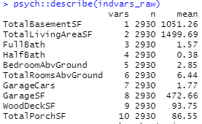

Figure 5: Mean and Standard deviation of raw independent variables

Again, we can see that our assumption of heterogeneity of variance is violated. Transforming this data using a ln-transform gives us the following distribution (Figure 5).

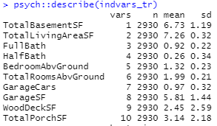

Figure 6: Mean and Standard deviation of transformed independent variables

Using these transformed variables, we can again run the multiple linear regression model to see if there are any improvements over the raw data. The results of this can be found in Figures 5 and 6. As before, I will address the results with respect to each independent variable individually.

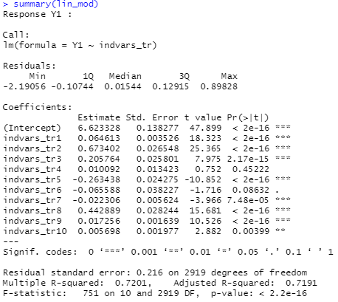

*Figure 7: Summary of output for transformed multivariate regression for SalePrice*.

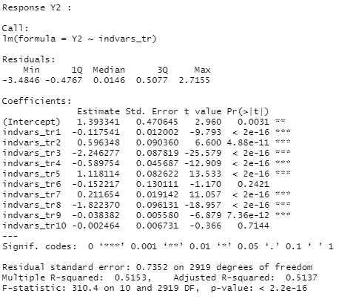

*Figure 8: Summary of output for multivariate regression for Age*.

*SalePrice (Figure 7)*

One significant improvement of this result vs. the raw data is that our intercept is much closer to 0. BedroomsAbvGround still gives a negative coefficient, which as discussed in the discussion of our initial model seems undesirable, but in this result TotalRoomsAbvGround also gives a negative coefficient. However, TotalRoomsAbvGround is not a significant predictor in this case (as in the discussion of our initial model) so this can be largely ignored. It is important to note that we observe a decrease in the R2 value - .6995, which is down from .7258 in the discussion of our initial model. I am not sure how to interpret this, but I do suspect that given more time to find a better way to transform the data I might improve this result.

*Age (Figure 8)*

The most significant change from part b in our model for Age is that TotalRoomsAbvGround and TotalPorchSF are no longer significant predictors of Age. Additionally, the coefficients for TotalLivingArea and BedroomAbvGround flipped sign from positive to negative. We see a decrease in our R2 value compared to our untransformed data. All of this is concerning given that this model is supposed to be an improvement over the raw data - but given the time I spend trying to standardize the data - I stand by the decision to keep the ln-transformed data instead of something more (like taking the inverse) or less (sqrt) extreme.

*Analysis of Residual Plots to Interpret Standardized Model.*

Scatterplots of our residuals vs. predicted values of both price and age reveal interesting findings about the fit of our model. Again, I will deal with price and age separately.

***SalePrice***

The graph of our residuals from SalePrice vs. our predicted SalePrice are shown in Figure 9. This scatterplot shows a quadratic trend around where PredictedPrice is equal to 12. This could be for a couple reasons. First, as mentioned before and as we will see in the analysis of residuals vs. predictors, while our ln-transformation worked for much of our data there are some parts of it which are still significantly skewed. This may be contributing to the quadratic trend in Figure 9. Additionally, we might be missing a feature or we could be seeing some correlation between the price of the house and the residuals.

*Figure 9: Residuals vs. predicted values for SalePrice*

***Age***

Our scatterplot of the residuals vs. predicted values of age harkens back to what I said about the intercept in part b. Our residuals look as though they are normally distributed about the mean, however there is a clear linear trend with positive slope as our predicted values for age increase. As mentioned above the intercept (~6 years) for age seems very low, and if it took on a higher value we would see exactly what we want in our scatterplot i.e. no trend in the residuals.

*Figure 10: Residuals and predicted values for Age*

Now we move on to a discussion about the plots of residuals vs. our independent variables. There are 10 predictor variables in this model, and to keep this problem from being 25 pages long (and from having to say the same things over and over again) I will stick to describing the figures that I find most demonstrative of the relationship between the residuals and independent variables. You can find all the plots in the folder labled “residuals vs. independent variables”. Also, since these scatterplots contain histograms of the independent variables, I am going to count them as histograms of our transformed data as well. I hope that is ok.

***Residuals vs. Independent Variables***

The big takeaway from plotting our residuals for SalePrice and Age vs. our independent variables is that our data transformation did a really great job of standardizing data, unless the value of the data could be 0. TotalBasementSF, GarageCars, WoodPorchSF, and TotalPorchSF all suffered from being well standardized except at zero. For example, we can see that our data for TotalPorchSF is nicely distributed except for the buildup of values at zero (Figure 11). Despite our troubles with normalization, our residuals look evenly distributed around a mean of zero. The plots of residuals vs. independent variables that were standardized well look very good. These variables include FullBath, HalfBath, BedroomAboveGround, TotalRoomsAboveGround, GarageSF. It seems with predictors that can only take discrete values our residuals are well distributed about a mean of zero, of which BedroomAboveGround is a good example (Figure 12). One independent variable which does not fit any of the trends discussed so far is TotalLivingSF. For this variable, the residuals are centered around a mean of zero but are concentrated quite densely near it (Figure 13). It is not clear to me whether or not this is a problem – or why we observe this – but it seemed necessary to point it out.

*Figure 11: Residuals of SalePrice vs. TotalPorchSF*

*Figure 12: Residuals of Age vs. BedroomAbvGround*

*Figure 13: Residuals of SalePrice vs. TotalLivingArea*

***Stepwise Multivariate Linear Regression***

Using stepwise regression for SalePrice, we first see that the only variable which lies above our inclusion threshold is HalfBath. After excluding this variable in our next model, we observe that no more variables lie outside our inclusion threshold so we stop here (not sure if that is right, but its what I got) (Figure 14). ANOVA of both our full and reduced model reveals no significant difference (p>.05) meaning the exclusion of the HalfBath variable did not affect the overall performance of the model (Figure 15).

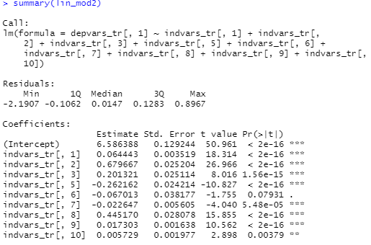

*Figure 14: Coefficients of reduced linear model. Note that all of our p < .15*

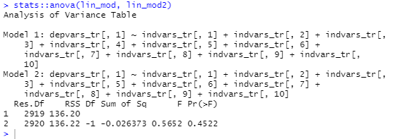

*Figure 15: ANOVA of full vs. reduced linear model for SalePrice*

***Data Re-Normalization***

All data are re-normalized using the bestNormalize package in R with the exception of WoodDeckSF (X9) where a yeojohnson transform was used due to technical difficulties. The resulting mean and standard deviation of transformed variables is as follows.



*Table 1: Summary statistics of transformed independent variables. Variable names are as follows X1 = TotalBasementSF, X2 = TotalLivingAreaSF, X3 = FullBath, X4 = HalfBath, X5 = BedroomAbvGround, X6 = TotalRoomsAbvGround, X7 = GarageCars, X8 = GarageSF, X9 = WoodDeckSF, X10 = TotalPorchSF*

It is worth mentioning that this method for standardization and normalization worked quite well for continuous random variables like TotalLivingAreaSF, and between fairly well and not well at all for our discrete random variables (probably because the range of their possible values is so low that it makes them behave more like binary random (or categorical) variables). Examples of each are provided below.

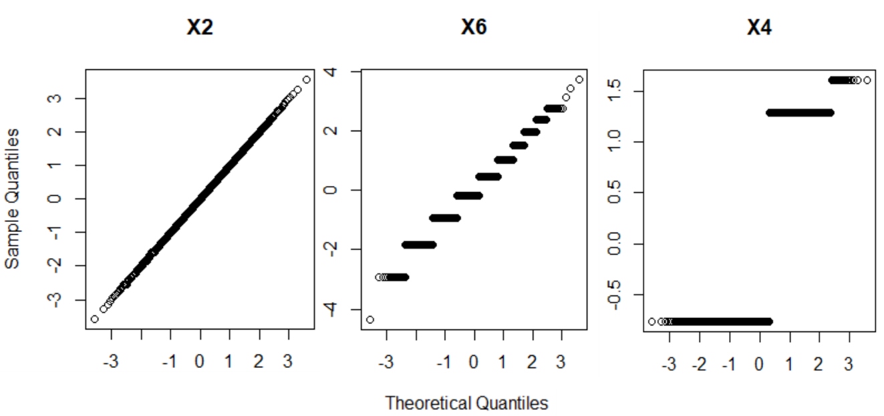

*Figure 1: Sample of normqq plots of transformed independent variables. X2=TotalLivingAreaSF, X6=TotalRoomsAbvGround, X3=FullBath. X2 and X6 were standardized differently in this figure then they are in the final data. Since the differences are very minor, I did not adjust them in this figure. X4 is presented as it is in the final data.*

The output of principal component analysis is reported in Table 2 and visualized in Figure 2. Based on these results, I would like to retain 6 principal components. In keeping with the goal of dimensionality reduction in PCA, I feel that 6 principal components which capture about 90% of our variance is a sufficient tradeoff for being able to drop the last four in favor of a simpler model.

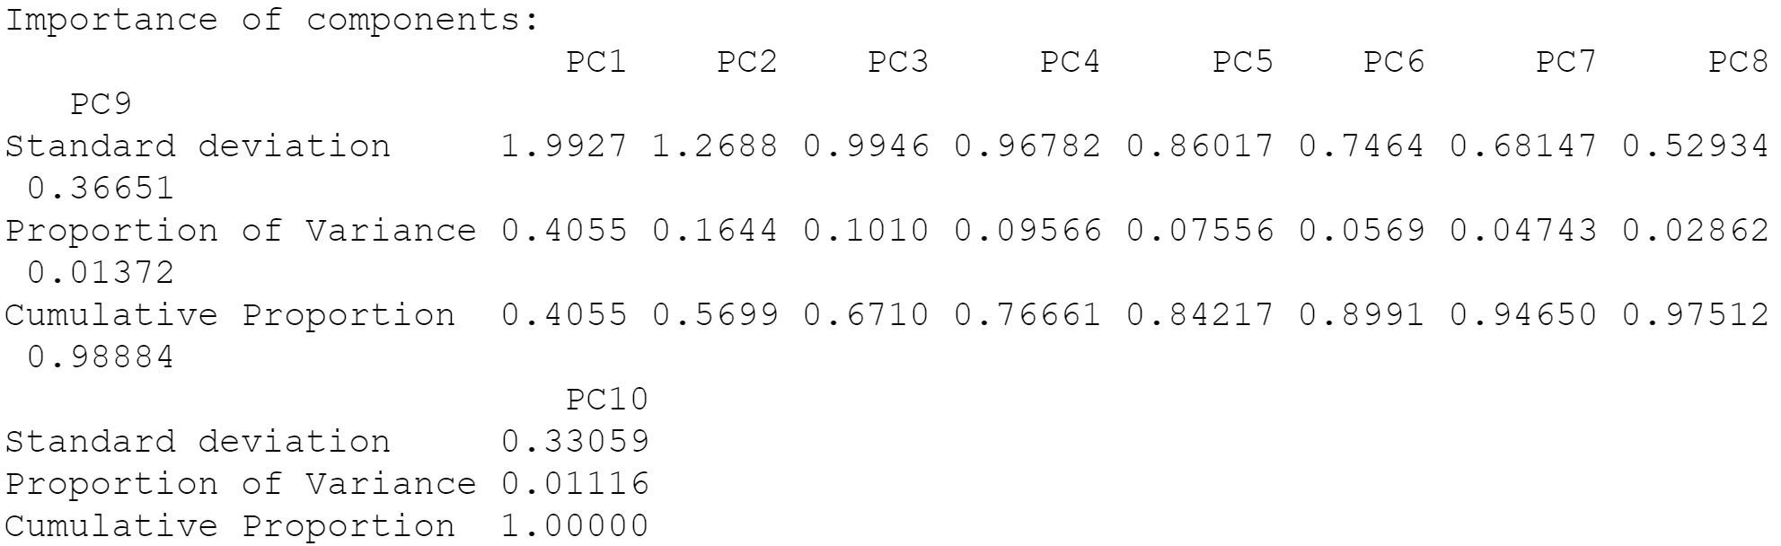

*Table 2: Output of Principal Component Analysis using all 10 independent variables X1-X10*

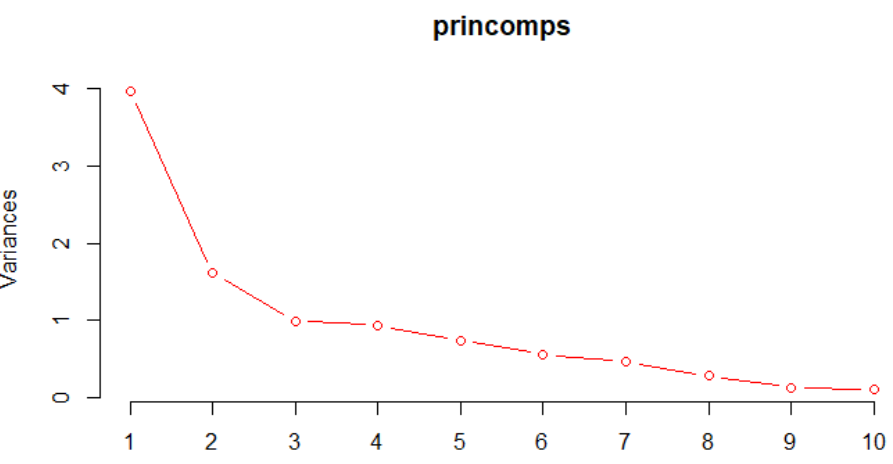

*Figure 2: Screeplot of Principal components and their variances*

Factor loadings for the 6 Principal Components we kept in our analyses are summarized in Figure 4.

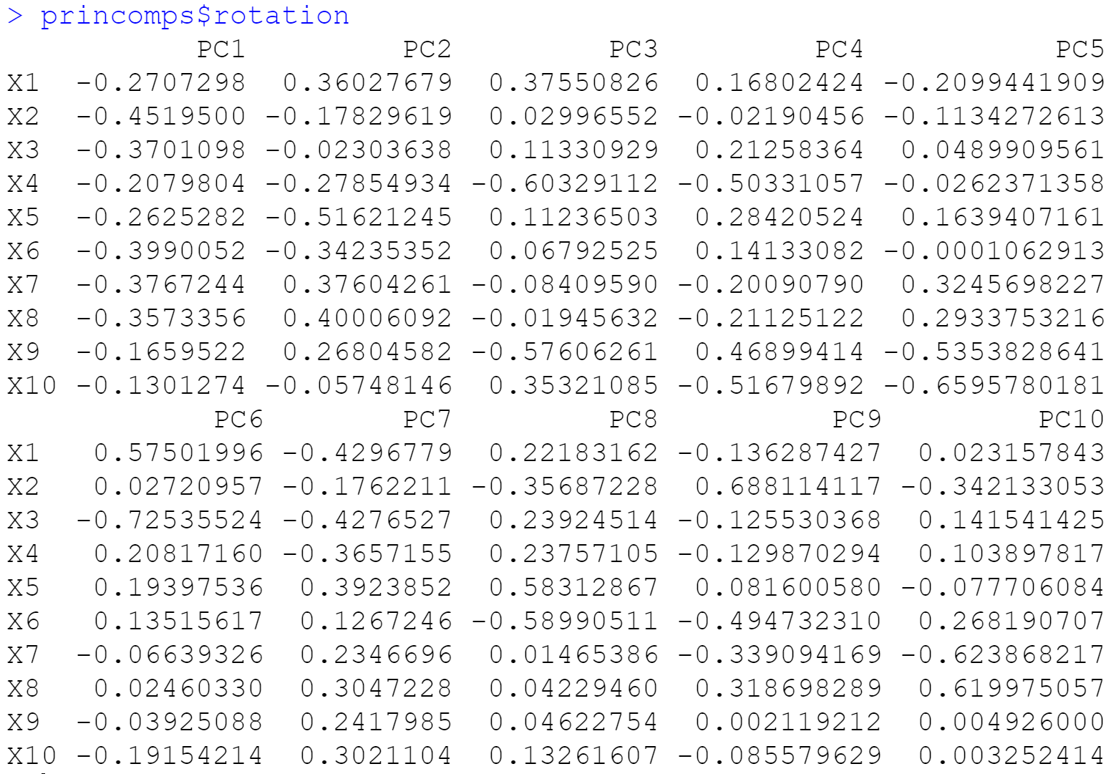

*Figure 4: Factor loadings for 6 retained principal components. For interpretability, the key is as follows:*

*X1 = TotalBasementSF, X2 = TotalLivingAreaSF, X3 = FullBath, X4 = HalfBath, X5 = BedroomAbvGround, X6 = TotalRoomsAbvGround, X7 = GarageCars, X8 = GarageSF, X9 = WoodDeckSF, X10 = TotalPorchSF*

***Interpretation of Factor Loadings***

PC1 is negatively related to all 10 of our independent variables, most strongly with regards to X2, X6, X7, and X8. Because X6, X7 and X8 are all very close in their loading, there may be something in the data that ties these three variables together. In fact across all 6 factors, we see that at least two of these factors load highly similar to one another.

PC2 has the highest magnitude on X5 followed by X8, X7, and X1. PC2 is more negatively related to our 10 variables, but only slightly (6/10). PC2 is hardly influenced by X10.

PC3 has mostly positive factor loadings (6/10) and is most influenced by X4, followed by X9, X1, and X10. 3 out of 4 of these are related to square footage, so PC3 may be capturing some related structure between these three variables. However, PC3 is relatively unaffected by X8, X2, and X6 with 2 out of those three variables being related to square footage.

PC4 is highly loaded on X10, X4, and X9. Note that X9 and X10 were also some of the greatest factors in PC3. However in PC4, their signs are flipped suggesting the inverse of whatever relationship is captured in PC3 may be captured by PC4. Interestingly, the lowest factor X2 was also one of the lowest factors in PC3 and again here the sign of the factor is reduced.

PC5 has mostly negative factor loadings (6/10) and is highest loaded on X10, X9, and X7 (again we see a recurrence of X10 and X9, this time both negative). PC5 is lowest loaded on X6, X4, and X6 suggesting that PC5 may be more concerned with relationships between the continuous random variables rather than those that take discrete values.

PC6 is very highly loaded on X3 and X1, suggesting this component may be capturing something about the relationship between these two variables. Of all 6 principal components, this has the most factor loadings below .10 with X8, X2, X9, and X7

General trends: The most common trend in this data is that X9 and X10 load highest on 3 out of 6 of our principal components given that they represent WoodDeckSF and TotalPorchSF it is hardly surprising that we find a relationship between the two. X2 is also frequently assigned a low load, being below abs(0.05) in 3/6 of our components. Overall, none of our principal components seem to disproportionately favor discrete or continuous random variables.

***Final Model Analysis***

***SalePrice***

Analysis of our linear model on SalePrice revealed all Principal Components but PC3 significantly affected our predictions. SalePrice is negatively affected by PC1, which makes sense given that the factor loadings on PC1 were negative for each independent variable. SalePrice is also negatively affected by PC4 and 5, while being positively affected by PC6 (although by a lesser magnitude than PC1, 4, and 5). Our intercept term is not significant at all, and is very close to zero. This is nice because we would expect the price of the home to be close to zero if all X1-X10 were zero (there wouldn’t be much of a home to sell). The fact that our intercept is not significant I believe just implies that expected value of SalePrice is not significantly different from zero when X1-X10 are zero. Note that this represents a significant departure from our regression that did not use principal component analysis where after normalizing our variables we obtained a highly significant intercept that had a value greater than zero. It seems PCA rectified this problem. Our R2 value is slightly higher using this model compared to the previous one – 0.727 vs. 0.7201. However, our residual standard error is greater using PCA – 0.523 vs. 0.216.

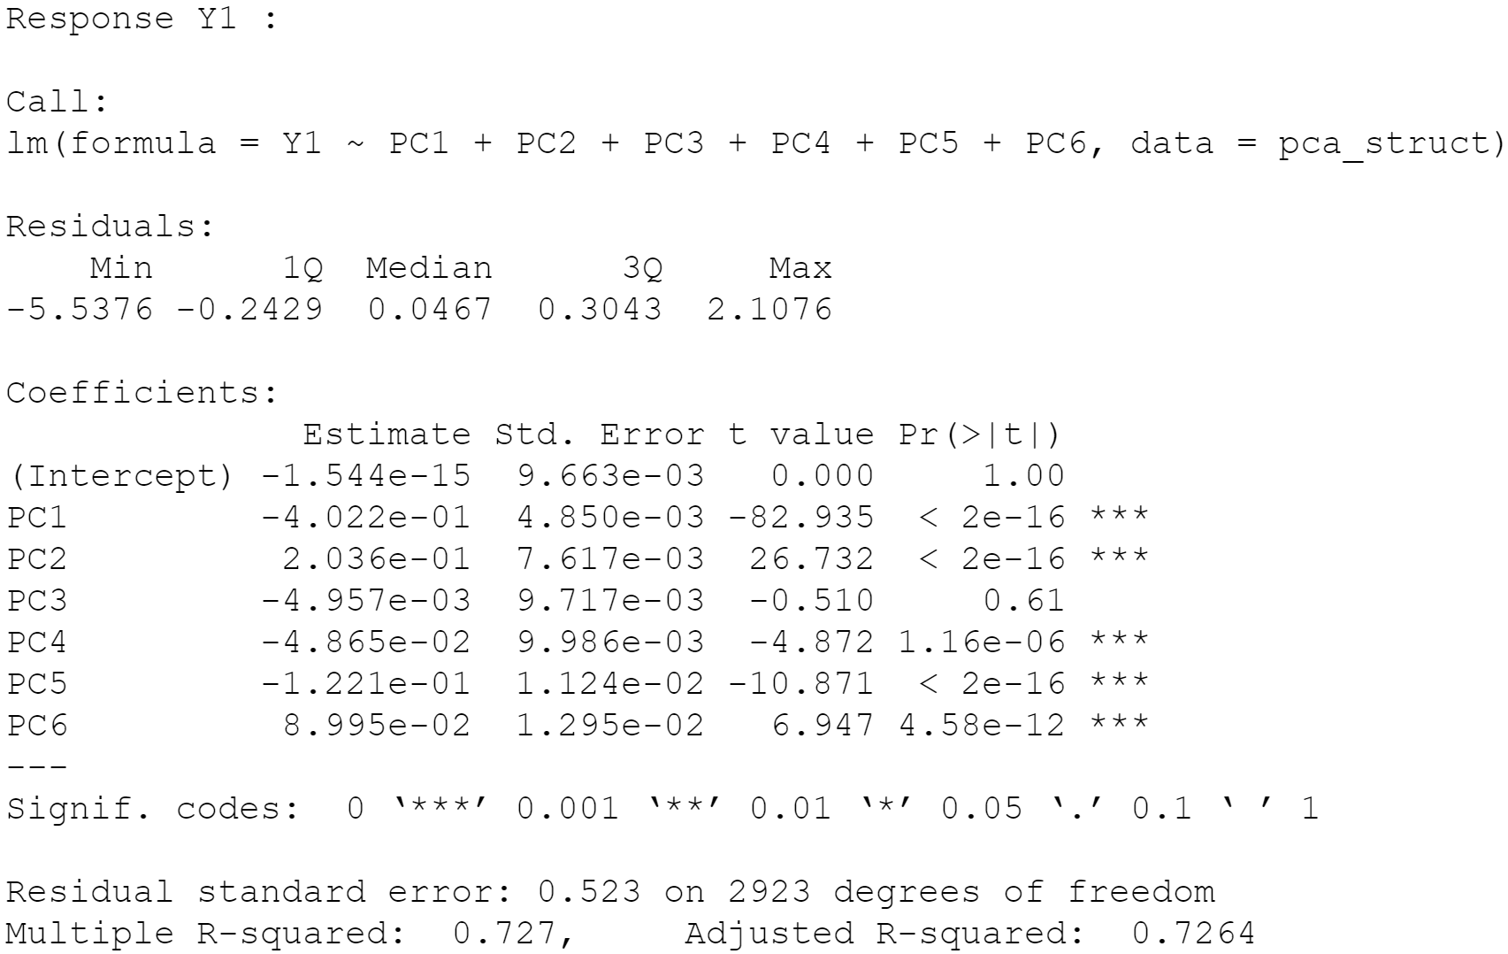

*Figure 5: Output of multivariate linear regression on SalePrice.*

***Age***

For Age, our linear model returned a significant effect of all six principal components. 4 out of 6 of these components (PC1, PC3, PC4, PC6) had positive coefficients meaning that whatever relationships in the data they capture, as they increase so does the predicted Age of the house. As with SalePrice, our intercept term is very close to zero and not significant at all. Similar to SalePrice, this has a nice interpretation that if we had a zero value for all X1-X10 we wouldn’t really be talking about a sellable home. Our R2 value here is lower than our previous model, with a value of .4559 vs. .5153. It may be worth noting that the linear model generated by including all 10PC’s outperforms our previous model with an R2 value of .57 (you can see this in the output generated by the source code). The current model has only slightly higher residual error than the previous one at .7384 vs. .7352.

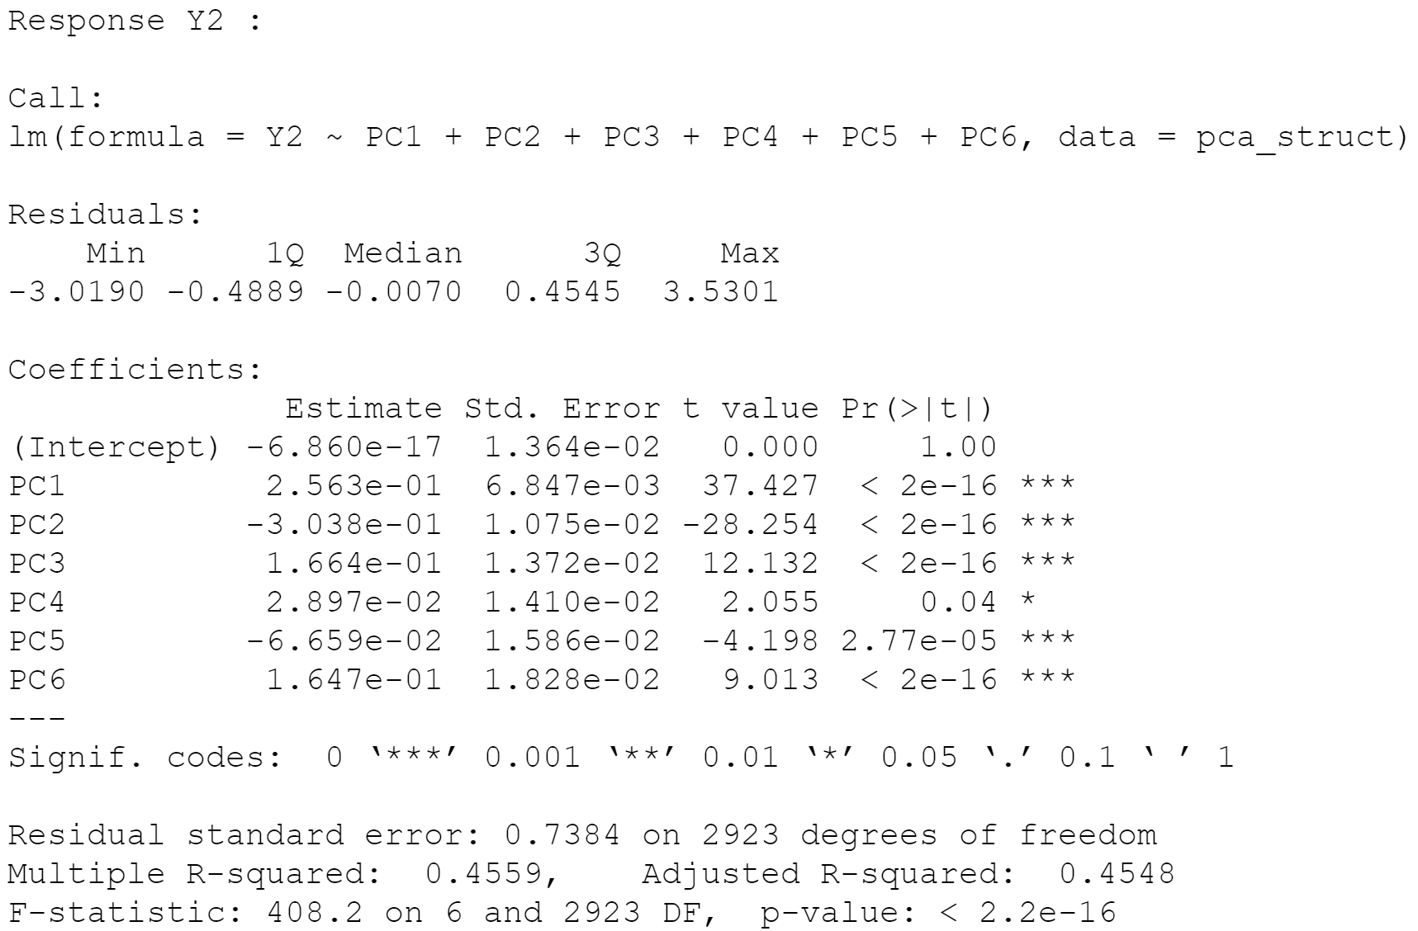

*Figure 6: Output of multivariate linear regression on Age*